--=================================================================================

--=============================== CIS 310 Exercise 1 ===============================

--=================================================================================

/\*

STUDENT NAME: James Cook

STUDENT ID: 5441819

SUBMISSION DATE: 1/12/2024

\*/

1. Do you spot any data redundancies in given data table? If so, what are the redundancies?
2. Explain the 3 types of data anomalies using below table. Update, Insertion, and Deletion.  
   -- Your explanation should refer to specific data as shown. Such as “ When Project manager is…….It causes…..”

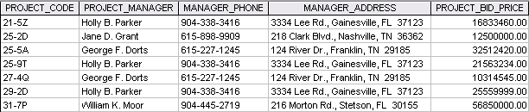

1. Data Redundancy: In this table, George has two entries, and Holly has three entries. Even though they have separate projects, their basic information, such as name, phone number, and address, repeat. These repeating entries are called data redundancy.

2a. Update Anomaly: When project manager Holly or George decides to change their phone number or address, it is possible to update the data easily visible to one’s eyes and leave out some outdated. This possibility of a mistake leads to an update anomaly where changing certain records may not update the entire relevant entries.

2b. Insertion Anomaly: Insertion anomaly could occur when we need to add a new project manager to the system without an assigned project. Empty records of the project code and bid price are not allowed, and making up fake data just to put the new manager in the system could lead to further problems.

2c. Deletion Anomaly: Yet another anomaly exists when Jane or William no longer manages a project. Deleting the project puts us in danger of deleting the entire record for Jane and William, even though they are still employed and should remain in the system. Since they manage only one project, their record can be easily wiped, whereas George and Holly have multiple entries and is “safer” from such anomaly to occur due to data redundancy. However, such structure that allows redundancy or anomaly to occur with ease should better be avoided.